We are absolutely thrilled you are interested to join us at Rohlik Group. By now we have spoken to you about your experience and personality in great detail. Next step is to find out how you tackle a task in reality.

**Payroll Specialist**

1. **Situation & Task**

The employee received this pay slip. The payroll calculator on the Internet calculated a smaller health insurance premium for him. How will you respond to the employee?  
  
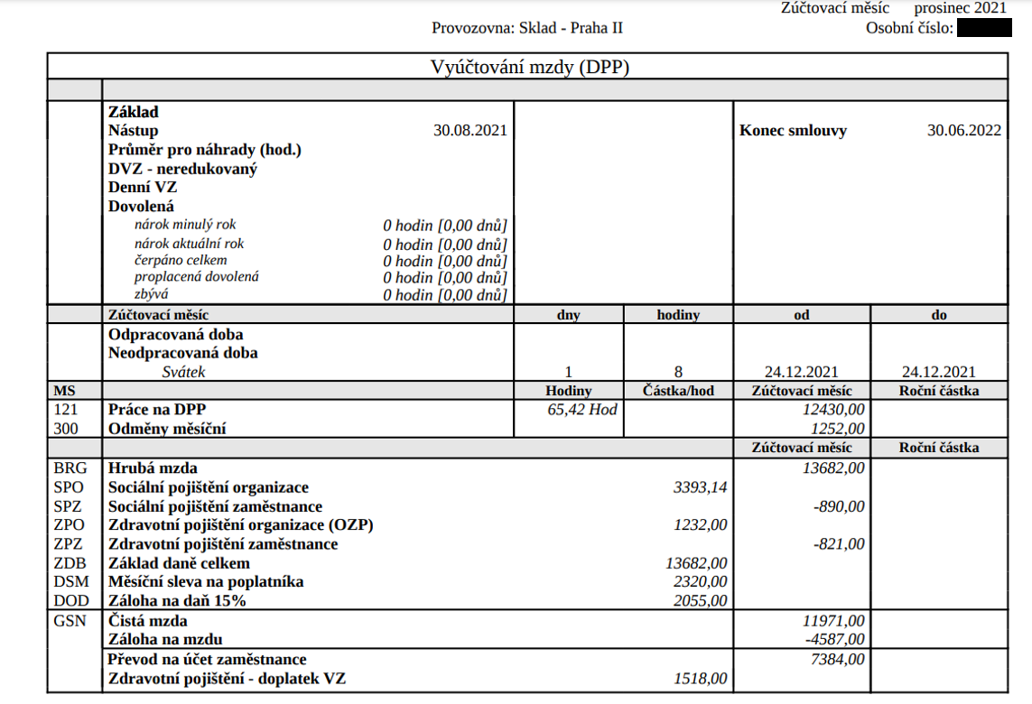

1. **Situation & Task**

The Labour Office asked us to fill in a monitoring questionnaire. Please complete only sections 2, 3 and 5. Use available data sources to complete the questionnaire. On a separate MS Excel sheet, leave the data work visible so we can see what process/functions/filters/contingency tables, etc. were used.  
  
Additional information:  
CZ0100 = Praha  
CZ0642 = Brno

**Format**

Result of the case study should be captured in a format of your choice that is easily shareable with us during the next meeting. We don’t need you to write essays, clear and consistent content is much more important to us. Please send us the presentation materials of your Case study 1 day prior to the meeting so we can review and get ready for the talk.